Experiment: 8
Steering Angle Variation in MIMO Beamforming Using MATLAB
P.VENKATA KISHORE
192412581
Objective – 1
To analyze the steering angle of a MIMO beamforming system by directing the beam towards different target directions using MATLAB.
MATLAB CODE:
clc;
clear;
close all;
angle = [-60 -30 0 30 60];
gain = ones(size(angle));
figure
% Steering Angles (degrees)
% Normalized Gain
polarplot(deg2rad(angle), gain,'o-','LineWidth',2)
title('Steering Angle Variation in MIMO Beamforming')

OUTPUT:
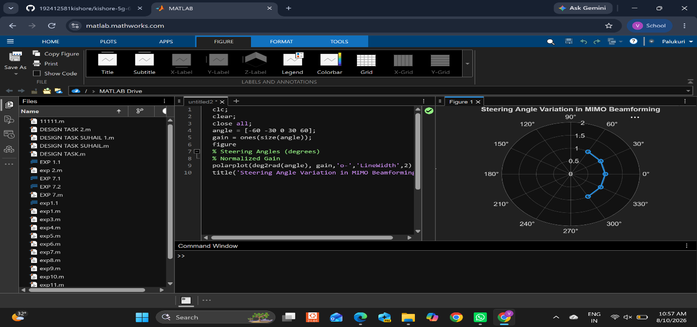

Objective – 2
To compare the array gain achieved for different steering angles in a MIMO beamforming
system using MATLAB.
MATLAB Code:
clc;
clear;
close all;
angle = [-60 -30 0 30 60];
gain = [9 12 15 12 9];
figure
bar(angle, gain)
grid on
% Steering Angles (degrees)
% Array Gain (dB)
xlabel('Steering Angle (Degrees)')
ylabel('Array Gain (dB)')
title('Array Gain for Different Steering Angles')

OUTPUT:

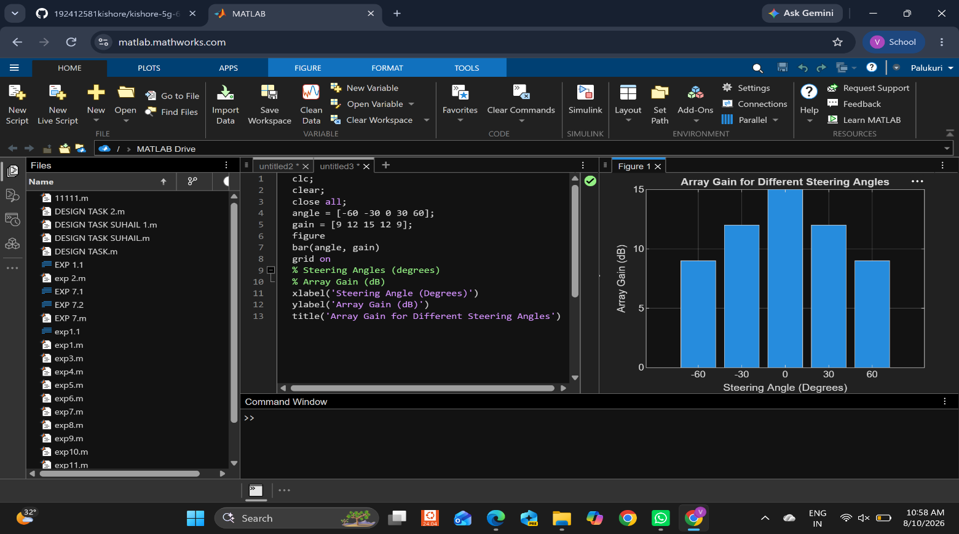

Objective – 3
To evaluate the beam direction error between the desired steering angle and the actual
beam direction using MATLAB.

MATLAB CODE:

clc;
clear;
close all;
desired = [-60 -30 0 30 60];
actual = [-58 -32 1 29 62];
error = abs(desired - actual);
figure
% Desired Steering Angle (degrees)
% Actual Beam Direction (degrees)
% Beam Direction Error
plot(desired, error, 'o-', 'LineWidth', 2)
grid on
xlabel('Desired Steering Angle (Degrees)')
ylabel('Beam Direction Error (Degrees)')
title('Beam Direction Error for Different Steering Angles')

OUTPUT:
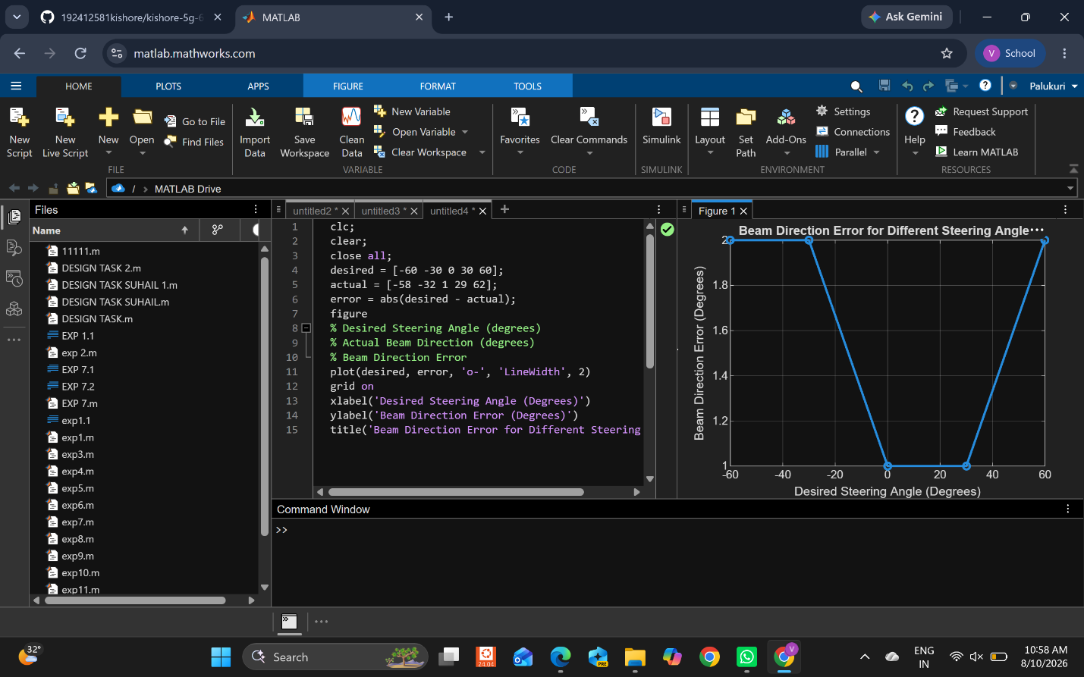

Result
The MATLAB analysis successfully demonstrated steering angle variation in a MIMO beamforming system. The results showed that beam steering effectively directs the transmitted energy toward different angles, while maintaining high array gain and minimizing beam direction error.

